Project Design Phase-II
Technology Stack (Architecture & Stack)

Date | 05/07/26
Team ID | SWTID-2026-9649
Project Name | Sports Hall Booking System by Service Portal(ServiceNow)
Maximum Marks | 4 Marks

Technology Stack Overview
The Sports Hall Booking System is developed using the ServiceNow platform. ServiceNow provides the application development, data management, automation, notification, and reporting capabilities required to build and manage the system.

Technology Stack
Technology / Component | Purpose in the Project
ServiceNow Platform | Core platform used to develop and run the application.
Application Navigation & Modules | Provides access to sports hall and booking features.
ServiceNow Tables | Stores sports hall information and booking records.
Business Rules | Performs server-side validation and booking-related logic.
Flow Designer | Automates booking-related processes and actions.
Scheduled Jobs | Executes automated tasks at scheduled intervals.
Notifications | Sends booking confirmations and status updates.
Reports & Dashboards | Displays and analyzes booking-related information.

Technology Stack Flow
ServiceNow Platform
↓
Application Navigation & Modules
↓
Sports Hall & Booking Tables
↓
Business Rules + Flow Designer + Scheduled Jobs
↓
Notifications + Reports & Dashboards

Technology Stack Diagram

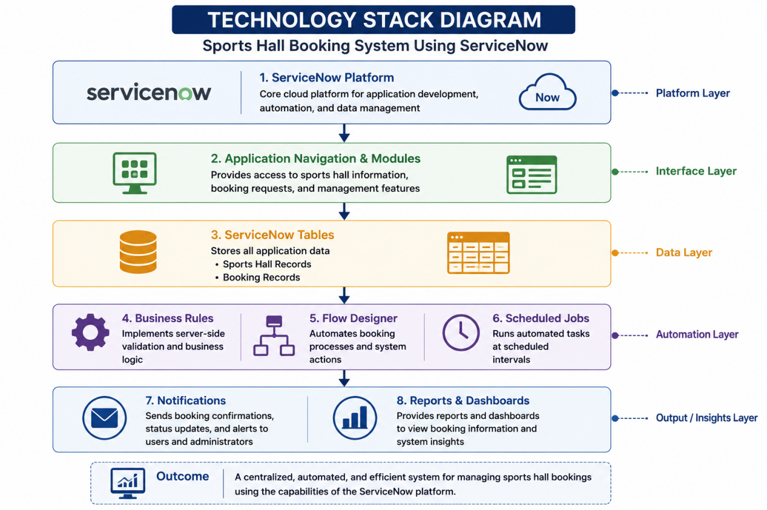

Conclusion

The selected technology stack provides all the necessary capabilities to develop a centralized and automated Sports Hall Booking System. Using ServiceNow helps organize booking data, automate processes, provide notifications, and support reporting within a single platform.

